**Monitoring via EVM:**

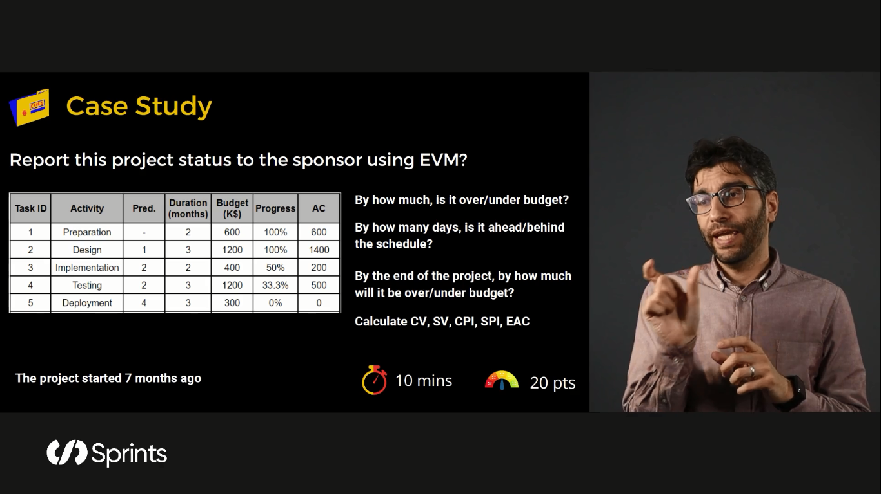

1. **By how much is it under/over budget?**

At this moment the project is over budget by 100K Dollars.

1. **By how many days is it ahead/behind the schedule?**

At this moment we are behind the schedule by 1 month (30 Days).

1. **By the end of the project, by how much will it be over/under budget?**

The project will be over budget by 500K Dollars.

1. CV: The cost variance is defined as the '**difference between budgeted cost and actual costs**, so CV = 3700 – 4200 = 500K Dollars over budget.
2. SV: To calculate SV, subtract your project's planned value (PV) from its earned value so SV = 13 – 14 = 1 month behind the schedule.
3. CPI: The cost performance index (CPI) is a measure of the conformance of the actual work completed (measured by its earned value) to the actual cost incurred: **CPI = EV / AC so CPI = 13/14 = 0.9**
4. SPI: The schedule performance index (SPI) is a measure of the conformance of actual progress (earned value) to the planned progress: **SPI = EV / PV so SPI = 2.8/5 = 0.56**
5. EAC: Estimate At Completion (EAC) is **the current expectation of total cost at the end of a project then EAC = 600 + 1200 + 400 + 1200 + 300 = 3700K Dollars.**